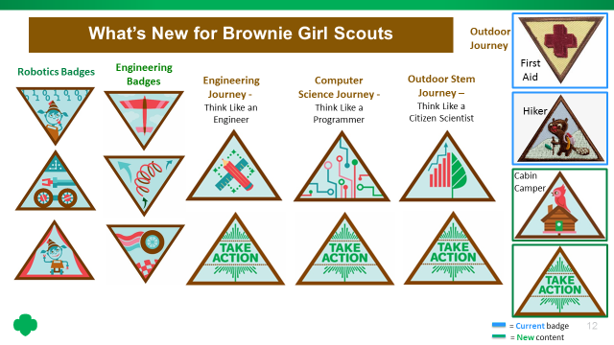

Cabin Camper

There’s nothing quite like camping—it’s a chance to spend time in nature and have fun with your friends or family. Every camping trip is a new adventure. Get ready to plan a camping adventure with your Girl Scout friends or family members!

- Help plan your camping trip
- Learn about camping gear
- Prepare a camp meal
- Learn a new camping skill
- Go camping!

When I’ve earned this badge, I will know how to plan a camping trip and stay overnight in a cabin* with my friends or family. *If you don’t have a cabin to use, that’s ok! You can sleep in a tent instead.

ROBOTICS BADGES – BROWNIES

Requirements, detailed directions, lists of materials required and supporting materials are all available on the volunteer tool kit (VTK), which is accessible to registered leaders. General requirements for each badge are available for purchase but you still need to use the VTK for detailed information and supporting materials. These are “unplugged” activities that do not require the purchase of robotics kits. These badges form a progression, so they must be done in order.

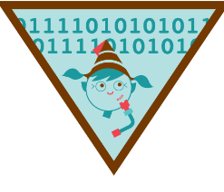
Programming Robots

Robots are simple machines made of many different parts that are programmed to run automatically. Programmers are the engineers that create step-by-step instructions, or algorithms, that tell robots how to understand and respond to their environment. Start by engineering a simple algorithm then learn about programming on paper, a “robot” Brownie friend, and on a device.
- Create a simple machine – Girls create a simple machine using an assortment of common materials/supplies
- Test your robot senses – Girls will use their senses to identify snacks
- Learn about programming – Girls create a program on paper to help a fellow Brownie (your robot) to color in an image without looking at it, and learn about algorithms and programming.
- Try simple programming – Girls write directions for a “robot” friend to go through a course
- Code a robot – Girls play a game from the Hour of Code website (https://hourofcode.com/us).

When I’ve earned this badge, I will know how robots use sensors and how to create simple programs that could be run by a robot.
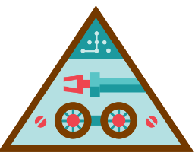

Designing Robots

Robot are simple machines that run automatically, made of many different parts, each with its own important job to help the robot. Sometimes, engineers design robots that look like or are inspired by humans, animals, and nature. Work in engineering teams with your fellow Brownies to design a robot inspired by a bumblebee, and build a robotic arm that helps others to extend their reach. After, it’s time to put it all together, and design your own robot that helps other people or animals! Test and share your robot prototype with other Brownies for ideas on how to make it even better.

- Explore how robots imitate nature – Leaders explain how engineers use biomimicry to design robots. Girls work in teams to draw a robot inspired by a bumblebee.
- Learn about the parts of a robot – Girls make a simple machine out of paint stirrers or wood slats, that mimics a robotic arm. Detailed directions are provided.
- Plan your robot – Girls design a robot that solves a problem for other people or animals. Brainstorm and sketch your ideas. They share your designs with other Brownies.
- Create a prototype – Girls will draw a prototype or build onewith common materials like cardboard, paper and string. Girls create a step-by-step program (series of instructions) for their robot prototype to “run”.
- Get feedback on your robot - Girls will get feedback from their fellow Brownies on how to improve their robot.

When I’ve earned this badge, I will know how to plan, build, and share feedback like an engineer by creating a prototype of a robot that helps other people or animals.
Showcasing Robots

After engineers build their robots, they show them to other engineers and enter them into challenges and competitions. Now that you have your robot prototype, it’s time to create a presentation and share your design with others. After, learn about robotics teams and competitions and see a robot in action!
- Create a presentation to share how you designed your robot – Girls create a presentation to share how they designed their robot (video, collage, show/tell).
- Tell others how you designed your robot – Girls share their presentation with friends and family or at a school or community event.
- Learn about robotics competitions – Girls go to a competition or science fair, or talk to someone who competes in robotics competitions, or watch videos online about robotics competitions.
- Learn about robotics teams – Girls join a team, or talk to someone who has been on a team, or learn about teams online.
- See robots in action – Girls go on a field trip to see a real robot, or talk to someone who has been in a lab or used a robot, or see a robotics lab online.

Note: Unlike the other Robotics badges, these Steps include options. You may be able to complete multiple steps, particularly for Step Three through Step Five, at once.
When I’ve earned this badge, I will have shared my prototype and design process with other. I will see a robot in action and learn about robotics teams and competitions.

ENGINEERING BADGES – BROWNIES

Each of the three new badges is designed to take two sessions. They use the GoldieBlox Making Things Zoom Kit (http://www.girlscoutshop.com/GoldieBlox-Brownie-Making-Things-Zoom-Kit).Each kit contains 6 sets of GoldieBlox parts for each badge. 2-4 girls can use each set. Purchase the kit at girlscoutshop.com for $99. Detailed directions for leaders are available ONLY on the Volunteer Took Kit (VTK)

Leap Bot Design Challenge

Every day you see a problem an engineer has solved. They design bridges so your car can cross a river, planes so you can fly to another place, and really tall buildings for lots of people to work or live in. To solve problems and create products that work, engineers have to think about all of the different things that might affect their design. Design, build, and test things like an engineer as you create your own Leap Bot out of GoldieBlox.
- Learn about springs Girls jump, which leads to a discussion of springs and gravity.
- Build your Leap Bot from GoldieBlox. It has a spring which powers it to jump.
- Create a way to test how well your Leap Bot performs. Girls design and build a mechanism to measure how high their Leap Bot jumps. Then they test their Leap Bot.
- Record the results of your test. Then they try using different springs and record the results.
- Share your results and discuss what happened when they used different springs.

When I’ve earned this badge, I will have learned about engineering, gravity, and force by building and testing a Leap Bot. I will know how to build and test a new product.

Fling Flyer Design Challenge
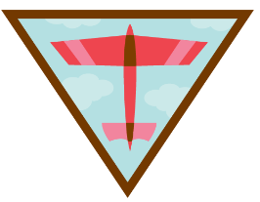

Engineers use their imaginations to solve problems. They invent and build things. Work like an engineer to create a Fling Flyer, an airplane made with GoldieBlox, and explore what keeps it and other things, like birds, planes, and space ships, in the air.

- Learn about forces that affect flight. Girls make paper airplanes, fly them, and learn concepts of thrust, gravity and lift.
- Design and build a Fling Flyer that is launched using a large rubberband.
- Test your Fling Flyer. Leaders discuss goals with the girls (flies higher, flies farther, stays aloft longer). Girls try to improve their flyers. Then, the leaders organize a competition.
- Analyze and share your results. The girls talk about what made some fly better.
- Brainstorm ways to improve your design

When I’ve earned this badge, I will have learned about the forces that affect flight as I design, build, and test a Fling Flyer. I will know how to design an investigation—and fine-tune my design after testing it, just like engineers.
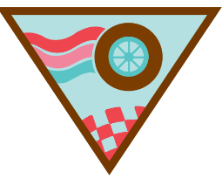
Race Car Design Challenge

When engineers design something new, they need to consider how forces like gravity and friction will affect their design. Race car designers add or create special features, parts of something, that help their car to go fast. Engineers create these features to make their products more useful. Design, build, and test your own race car using GoldieBlox to explore how science can make a faster race car!

- Learn how design can affect speed. Let the girls roll an assortment of balls. Leaders help them learn about speed and friction. Leaders discuss why cars have wheels (to reduce friction).
- Design and build your race car.
- Design a racetrack with a ramp.
- Conduct a fair test and record results. Then they build racetracks that can handle two cars at a time, and test again.
- Share what you learned

When I’ve earned this badge, I will have designed race cars and race tracks, then carried out “fair tests” to learn how design affects speed.

THINK LIKE A CITIZEN SCIENTIST – BROWNIE
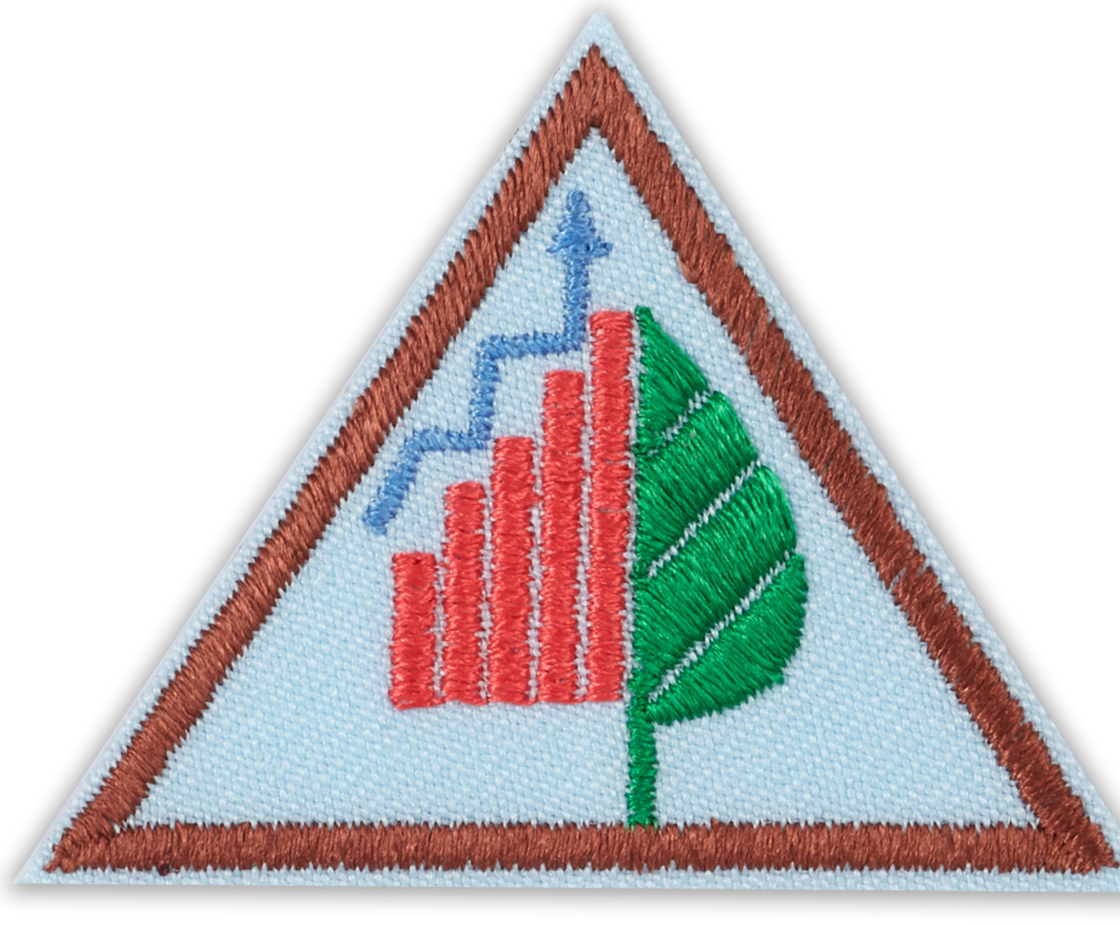
In this journey, scouts do a citizen scientist activity from Scistarter.com. Detailed instructions and supporting materials for this journey are available only on the Volunteer Took Kit (VTK). You MUST create a Girl Scout Scistarter account. They have set up a part of their website just for Girl Scouts, where they have videos about projects that have been pre-selected for Girl Scout troops. Sign up atscistarter.com/girlscouts/volunteer/landing. It is better if you have internet access and devices for the girls to access the website directly. If this isn’t possible, you can download some of the information or describe projects from the website.
Session 1: Learn to observe
- Quick Change game: In pairs, girls observe each other for 15 seconds, change one thing about their appearance, and then try to guess what the other girl changed.
- Discuss what scientists do and introduce citizen scientists. Citizen scientists are ordinary people that help scientists with their research projects.
- Show the Brownies half of the project videos on Scistarter in the Girl Scout section. You can do this online, download the videos in advance onto your device, or just describe the projects to the Brownies. You can only get to these videos from your Girl Scout SciStarter account at scistarter.com/girlscouts/volunteer/landing.
- Play Kims game: The girls observe 10-15 small items that are displayed, then covered. They record their observation, and compare that with reality. Leaders run the game again but this time remove an item, and see if the girls can identify the change.
- Introduce the concept of a take action project, and begin brainstorming ideas. Leaders can use the “take action guide” from the VTK as a resource.
Session 2: Learn to collect data
- Each girl makes a field notebook by folding paper in half, stapling the middle and decorating with markers/stickers. (Or, the leader provides the notebooks and the girls decorate theirs.)
- Show the Brownies the other half of the videos on Scistarter in the Girl Scout section. Girls choose one project to do in session 3.
- Snails Field Notes Activity: Leaders print, copy, color and cut-out paper snails, along with directional signs (north, south, east and west) from the VTK, and distribute them in the troop meeting space. The Brownies observe the snails and take “field notes” about what they find (and where) in their field notebooks. They share results, produce a map of their results and discuss patterns.
- The leader guides the troop to brainstorm about possible take action projects, building on the list started in session 1.
Session 3: Be citizen scientists
- The troop does the citizen science project that they selected in session 2, one that was featured in the project videos in the Girl Scout section of the Scistarter website. For example, this could be taking photos of clouds at specific times, taking photos of the night sky one hour after sunset, observing the squirrel population at school, or creating a picnic for ants and reporting on their behavior. Most of these activities will require a cell phone or tablet to record and report data.
- The troop chooses a take action project, using the “fist to five” method of voting (described in the VTK) which allows them to show degrees of interest, not just yes/no.
Sessions 4 & 5: Take action project
- Troop plans and does their take action project. For this journey, a logical take action project would be for the girls to raise awareness of citizen science. This could be show-and-tell in their classroom, making a presentation to another troop or at a Girl Scout, school or community event, or having a booth/display at a Girl Scout or community event to promote citizen science.
Session 6: Award badges, celebrate, recap and do GSUSA Survey

THINK LIKE A PROGRAMMER – BROWNIE
This journey teaches how to think like a programmer (but not to do actual programming). These are “unplugged” activities, which do not require access to computers. Detailed instructions and supporting materials for this journey are available only on the Volunteer Took Kit (VTK). Many of the activities in this journey come from Code.org, a non-profit dedicated to giving every student in every school the opportunity to learn computer science. See www.code.org. There are instructional videos for many of these activities. Sessions 2 & 3 of the Brownie & Junior journeys are quite similar.
Session 1: Introduction to algorithms
- Morse Code Activity: Girls write their name in Morse Code (code sheet provided in the VTK).
- Girls discuss what computer programmers do.
- Algorithms in real life: An algorithm is a set of steps you follow to complete a task. Girls discuss the steps it takes for them to get ready for school – their algorithm for getting ready for school.
- Girls learn about paper programming. VTK provides a worksheet for the girls and a link to an instructional video.Working in pairs, the girls create paper programs to create specific images in a 4x4 grid on a sheet of paper. Then they DEBUG (test) other group’s programs.
- In teams, the girls run a relay race, where each person does one step of a 4x4 paper program as the goal of their turn.
- Leaders introduce the concept of a take action project, and begin brainstorming ideas. Leaders can use the “take action guide” from the VTK as a resource.
Session 2: Functional programming
- Girls do a graph paper programming activity in which they write simple instructions (using arrows) on how to fill in squares in a 3 x 3 grid. Then they debug their instructions.
- Leader explains how programmers “deconstruct” an activity into a series of smaller steps.
- Functional Suncatchers: The girls talk through how to write a “program” to make a suncatcher (i.e. bead, knot, bead, knot, spacer, knot, bead, knot, etc.). Then, leaders introduce the concept of “functions”, which are a set of instructions (i.e. bead, knot, bead, knot, spacer, knot), and have them write their program using functions. Leaders introduce the concept of “variables,” in this case a special bead. Then, the girls make their suncatchers using their “programs.”
- The leader guides the troop to brainstorm about possible take action projects, building on the list started in session 1.
Session 3: Innovation and Rapid Prototyping
- Walk the Line: Girls write an algorithm for another girl to walk a line (masking tape path on the floor) while blindfolded.Then, they test it.
- Personal Innovations: Girls choose a special skill (i.e. play soccer, draw, dance), and choose something they could teach someone else how to do (i.e. kick a ball into the goal, draw a bunny). Then, working in small groups, they write an algorithm (at least three steps) for one of these. Then they test their algorithm by teaching other girls.
- Girls brainstorm technological innovations (e.g. self-driving cars, house-cleaning robot). Then they draw a prototype, post the drawings on a wall, and view their gallery of prototypes.
- The troop chooses a take action project, using the “fist to five” method of voting (explained in the VTK) which allows them to show degrees of interest, not just yes/no.
Sessions 4 & 5: Take action project
- Troop plans and does their take action project. This could be an activity like making an inspirational video, a class show-and-tell, making inspirational posters for their school, or teaching an algorithm activity to others.
Session 6: Award badges, celebrate, recap and do GSUSA Survey

THINK LIKE AN ENGINEER JOURNEY – BROWNIES

This journey is designed to teach girls a basic design-thinking process (brainstorm, design, build, test, share, reflect). Detailed information on how to lead this journey is available on the Volunteer Tool Kit (VTK). This document is designed to give leaders an overview of this journey. Basically, during the first three sessions, the girls will do a design challenge at each session, in which they will build something using everyday materials. Interspersed among the three design challenges, the girls will brainstorm, discuss, and choose a take action project. The VTK has guidelines for leaders on take action projects, as well as examples of projects. Then the troop plans and does their take action project in sessions 4 and 5. They wrap-up the journey in session 6.
Session 1:
- Troop discusses - What is an engineer?
- Introduce Design Thinking Process: 1) brainstorm & design, 2) build & test, and 3) share and reflect.
- Design Challenge – Helping Hands (30 minutes): In small groups, the girls build an assistive device using paint stirrers or wood slats (or cardboard), and brass fasteners. They connect the wood slats with brass fasteners to make an accordion like device that people can use to grab something from a distance. Leaders run this activity following the Design-Thinking Process.
Session 2:
- Troop discusses fun ways to interact with water and water usage.
- Design Challenge – Water Collection Device (30 minutes): In small groups, the girls build a device that helps people who don’t have enough water. This could be a rainwater collector or a device that brings water from a lake or stream.They makea prototype,using materials like construction paper, empty cans/bottles, tape, markers, glue, string, toilet paper rolls.Leaders run this activity following the Design-Thinking Process.
- Begin brainstorming take action projects, using a handout that has guidelines and suggestions.
Session 3:
- Review take action ideas.
- Design Challenge – Pop Fly (30 minutes): In small groups, the girls build a device using paint stirrers or wood slats to launch a ping pong ball into the air to hit a target.Leaders run this activity following the Design-Thinking Process.
- Girls choose a take action project – they vote using “fist tofive”(explained in the VTK), which allows girls to show levels of interest, not just yes/no.
Sessions 4& 5:
- Girls plan and do their take action project. Suggested projects include: the girls building a rain barrel, or doing a show and tell presentation about engineering, or running an engineering workshop for kids.
Session 6: Award badges, celebrate, recap and do GSUSA survey

